Here are some links for books to check out:
http://www.thegenderbook.com/

https://www.amazon.com/Beyond-Magenta-Transgender-Teens-Speak/dp/0763673684/ref=sr_1_1?ie=UTF8&qid=1505838133&sr=8-1&keywords=beyond+magenta

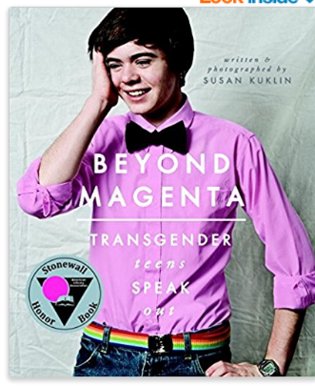

https://www.amazon.com/Gender-Quest-Workbook-Exploring-Identity/dp/1626252971/ref=pd_cp_14_4?_encoding=UTF8&psc=1&refRID=SAPT95HG15ATSN7E48W0
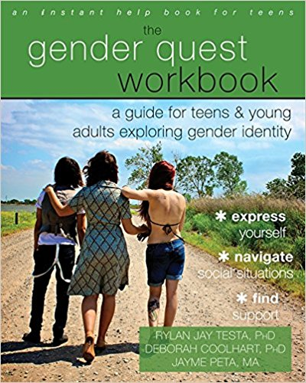

https://www.amazon.com/Trans-Bodies-Selves-Transgender-Community/dp/0199325359/ref=pd_rhf_cr_s_cp_11?_encoding=UTF8&pd_rd_i=0199325359&pd_rd_r=06RXTDTBTMDHPE83S981&pd_rd_w=Y2a0D&pd_rd_wg=stMej&psc=1&refRID=06RXTDTBTMDHPE83S981 (this may be one to review to make sure it is age appropriate for your child)

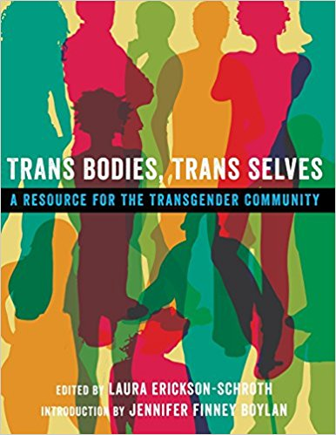

https://www.amazon.com/Transgender-Child-Handbook-Families-Professionals/dp/1573443182/ref=pd_sim_14_6?_encoding=UTF8&psc=1&refRID=2PMPSS2TWR98713B6STR

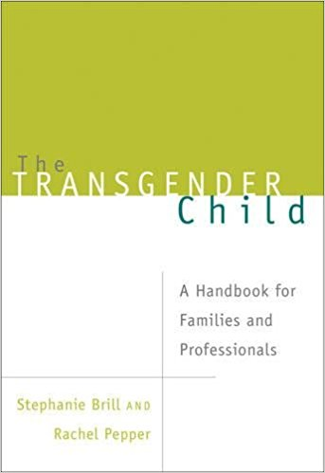

https://www.amazon.com/Gender-Born-Made-Gender-Nonconforming-Children/dp/1615190600/ref=pd_sim_14_3?_encoding=UTF8&psc=1&refRID=F02VCAYQHR4F6KPZM3PV

